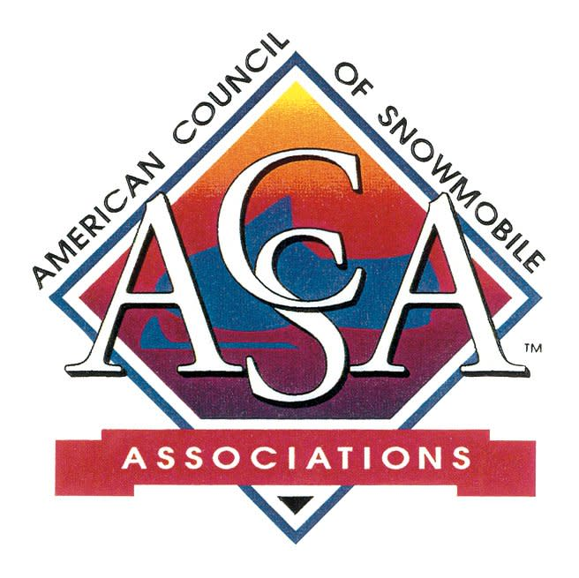

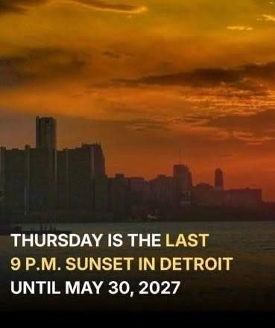

Earlier sunsets means we're just that
much closer to winter!

Yellowstone Permits Open
National Park recently announced that, beginning Saturday, August 1, individuals may apply to the 2026–27 winter lottery for permits to snowmobile in the park without a commercial guide.
The Non-Commercially Guided Snowmobile Access Program was authorized in 2013 and allows permit holders to enter the park for up to three days with a group of up to five snowmobilers.
This year’s lottery will be open August 1–31 on recreation.gov. Successful applicants will be notified in early September.
Unclaimed or canceled permits will be made available beginning October 1. There is no waiting list.
Trips can be up to a maximum of three days in length. Permits cost $40 per day, with a $6 application fee.

US Forest Service
The US Forest Service continues to confront a worsening wildfire season. Fires have burned nearly 3.9 million acres this year through Wednesday, or nearly a million more than a year ago, according to the National Interagency Fire Service (NFIC).
At a Congressional Hearing this week Chief Schultz said the Forest Service hired 11,800 seasonal firefighters for this year — 500 more than its initial goal — and has around 28,000 total employees available for fire-related duty when “red-carded” staff qualified for such work are included.
The NIFC recently increased the national wildfire preparedness level to its highest category on a scale of five. Schultz said the Forest Service is operating on a “full suppression” strategy for all fires.

Chief Schultz also reported the agency is well on its way to its annual timber harvest goal of 3.2 billion board feet, which would exceed last year’s and make progress toward President Donald Trump’s directive to boost the nation’s production.
The national forests provide less than 6% of the country’s saw log production, Schultz said, meaning the great majority of lumber comes from privately owned land.
In addition, Chief Shultz provided an update on employees and procedures in a memo on Wednesday. He stated that employees will learn more about their futures with the agency soon, lateral reassignments and management-directed reassignments for senior non-unionized employees at the GS-14 and GS-15 pay grades will begin this week.

Canadian Fires
Currently there are 800 active wildfires. In total this season, there have been 3,137 fires and 1.4 million hectares (1 hectare = 2.5 acres approximately) burned. There were about 100 fewer fires at this time last year, but a more significant area burned, 4,614,713 hectares.
Natural Resources Canada announced a total investment of $1.25 million for 6 projects that will strengthen wildfire preparedness and response capacity.
According to Canadian sources, some of the wildfires were caused by lightning, while others were caused by human activity. Dry vegetation, hot weather and lightning can all contribute to wildfire activity.

Half of Canada's fires are in remote areas with no road access. Impossible to fight, they are left to burn.
The US has supplied substantial personnel and aviation to support Canada's 2026 wildfire response, deploying firefighters, incident managers and support staff alongside airtankers, smokejumpers and other aviation assets under long-standing bilateral arrangements.
Many areas of Canada and the US have been considered significant high risk for health risks the last few weeks.

The Endangered Species Act
Changes
The Trump administration has pulled back the reach of the Endangered Species Act, eliminating a rule that prohibited private landowners from altering the habitat of protected species.
Congress intended the ESA to protect endangered animals from being killed, wounded, captured or harmed, but the rule imposed by bureaucrats transformed the law into a sweeping land-use regulation, administration officials said.
“For years, federal agencies abused the ESA to obstruct lawful land use and burden American families and businesses,” Interior Secretary Doug Burgum said in a statement.
The ESA prohibits specific acts such as shooting or pursuing protected species. In 1975, the U.S. Fish and Wildlife Service defined the more general “harm” as meaning to degrade habitat.

The U.S. Supreme Court upheld the definition in 1995, though Justice Antonin Scalia said in a dissent the definition was not grounded in the law Congress passed.
The ESA prohibits acts that harm individual animals, not acts that indirectly or accidentally injure a population of animals, according to Scalia. Three decades later, the Trump administration is embracing Scalia’s dissent.
The USFWS and National Marine Fisheries Service posted Federal Register notices July 13 that they were simply rescinding the longstanding definition of “harm.”
The ESA will still prohibit acts such as pursuing, shooting and trapping protected species. But dropping the definition of “harm” will restore the act to its original intent and eliminate regulatory burdens, according to the Trump administration.

Harley Davidson Changes Coming
Harley-Davidson executives struck an optimistic tone during the company’s second-quarter earnings call this week, saying the early stages of its “Back to the Bricks” turnaround strategy is showing gains in working closer with dealers and showing gains in dealer profitability, retail sales and inventory health, causing Harley to raise its full-year guidance.
The new plan pivots toward lower-priced models—a returning Sportster at around $10,000 and a new entry-level Sprint—to pull in younger and first-time riders. Harley's US registration declined 49% in 2019 to 34% in 2025—also addressed in the new plan.
The upbeat outlook came following an S&P Global Ratings cut Harley-Davidson (NYSE:HOG), to junk status two weeks ago, citing the company's plan to sell more lower-cost motorcycles as part of a push to lift revenue.

It has not been smooth sailing for America's most famous motorcycle company for a while. Sales have spent the last two decades in decline. The company's demographics and baby boomer customers are not the new generation of buyers.
However, the optimistic outlook is back - and that is good for all of recreation!

Meanwhile...In DC...
The House is getting ready to leave town for a 5-week summer recess. That's why they have been racing to complete some of their tasks and voting on bills that have been gathering dust.
The Senate will be in session until August and will return mid-September.
The current federal funding expires September 30. The House, trying to be proactive, passed a bill that extends government funding through December 4 hoping to avoid an ugly shutdown battle on September 30th.

Never Say Goodbye....
As Bon Jovi sang, Never Say Goodbye...the importance of holding on to longtime friends for more fun and good times.....
That's the way we felt when we first heard from Joel Mellenthin that he was closing up the MSPN business after nearly 40 years.

We thank Joel and the MSPN staff for the decades of passion and dedication -- and wish each and every one of them the best as they move on to new chapters! And of course, we wish Joel and Kathy the very best as they spend more time in the sun than snow and more time on trails than in the print shop!
Best Wishes to all of the MSPN employees...Thanks for the memories!

Snowmobiling continues - even in the 90 degree days of summer! Trail work of course continues - as does the fun, from watercross to parades! Love the passion!!





UPCOMING EVENTS

July 26: America 250 Trail Grant Deadline
July 29: Michigan Board Meeting (Zoom)
July 31: BRP SNOW PASS GRANT Deadline
August 1 - 2: Nebraska Campout
New location: Lead, SD
August 7 - 9: Washington Summer Meeting/Campout
Pashastin/Blue Shastin RV Park
August 25: New York Board Meeting (online)
September 1: POLARIS TRAIL GRANTS Deadline

GET SOCIAL WITH US!
Follow us on Facebook
Click Here
P.O. Box 1670, Brighton, MI 48116
(517) 351-4362 | Email

