﻿==== ACSA E-News ====





Oh the weather outside is frightful.....
from snowstorms to rainstorms to hot and humid.
Here's hoping you all are enjoying summer in your area!

Forest Service Trail Grants
APPLY NOW!
If your club works with the US Forest Service - this is a great opportunity for you!
If your club rides in a US Forest - think about partnering with the local club on projects. Everyone has a to-do list, but there isn't always money available.
Now there is money available! Yes - it's summer and many snowmobile clubs are not regularly meeting -- but please think about pulling that list out and see if you have something that will fit this program. Now is the time!
The America the Beautiful Foundation and the US Forest Service have developed the America 250 Trail Grant Program.
At least ONE PROJECT will be funded for every US Forest!
250 grants! $5,000 - $50,000!
It's a short turn around!!
Initial award announcement: July 26, 2026
Completion deadline: December 31, 2027
Deferred Maintenance
Disaster/Climate Events
Parking Lots/Signs
Less Staff - More Volunteers Needed
Think of Trails, brushing, repairs, bridges -- the basics!
Need permitting, engineering, surveys -- here's your grant!
What are the critical barriers? List them!
List all of the benefits of the project!

Don't have Agreements with the Foret Service in place?
Don't worry -- apply! Use your own application!
Click here for the America 250 Grant Trail info.
There is also a PowerPoint available -- ACSA can share that with you and your State Snowmobile Association also can.
Just contact ACSA or your State.

Chainsaws in Wilderness?!?

﻿Wilderness advocates are protesting against another national forest in Idaho allowing the use of chainsaws in the wilderness.
On Wednesday, the Missoula-based Wilderness Watch learned Payette National Forest Supervisor Matthew Davis had authorized chainsaw use in designated wilderness, which includes the northwestern part of the Frank Church-River of No Return Wilderness.
“We absolutely do not believe these authorizations are legal under the Wilderness Act or the National Environmental Policy Act. Not only do these moves go against the mandate of the Wilderness Act prohibiting the use of motorized equipment in Wilderness, they could also set a dangerous precedent for the management of Wilderness across the country,” said Matt Koehler, Wilderness Watch Media director, in a statement.

Will the Forest Service HQ Move
to Salt Lake City?
This week a group of unions, environmental and civic organizations, and local governments has filed a lawsuit challenging the planned restructuring of the U.S. Forest Service, which includes moving the agency’s headquarters to Salt Lake City and closing regional offices and research facilities across the country.
﻿The plaintiffs are alleging that the reorganization would impair the Forest Service’s ability to manage national forests, and they are seeking a preliminary injunction to prevent the USDA administration from moving forward with its reorganization plan.

Changes to the Endangered Species Act
Moving Along
Proposals from the Trump administration to limit the scope of wildlife protections by changing the definition of a single word advanced Tuesday through a White House review.
The proposals from the Fish and Wildlife Service and NOAA hinge on the meaning of the word “harm” found in the landmark Endangered Species Act. The law prohibits harm and other injury to protected wildlife.
﻿Republican and Democratic administrations for decades have defined the term to encompass significant destruction of a species’ habitat. That interpretation was upheld in a 1995 Supreme Court ruling. But under the Trump administration, wildlife agencies have proposed to narrow the interpretation of "harm" in the law and exclude habitat destruction from its reach.

Forest Fires

So far in 2026, Utah wildfires have burned more acres than the previous five years combined — and it’s still early July.
Driven by the explosive growth of the Cottonwood and Babylon fires — two of the nation’s largest — flames have consumed 357,173 acres and counting as of July 6.
﻿That surpasses Utah’s cumulative sum from 2021 through 2025, which was 355,944 acres according to data from the National Interagency Fire Center.

Times Are Changing!

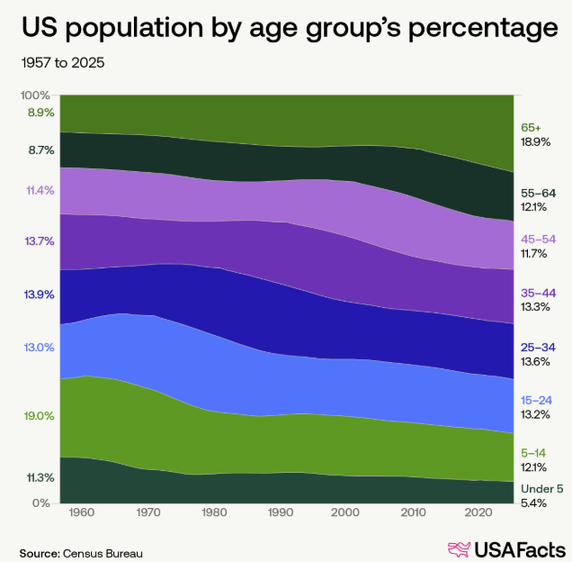

The US population is changing! The largest age group now is people who are 65 and older.
The number of births in the US hit a record high in 1957:
4.3 million - and they turned 65 in 2022.
The 2nd largest age demographic is those people between ages 25 - 34.
Last year, for the first time ever, recorded nearly 30% of the population living alone.

Hoping you all had a Happy 4th of July.....this particular bison, Clyde, certainly did! He enjoyed a margarita and bourbon before the Cody Wyoming Parade.
﻿If you've ever been to Cody, you have most likely been to the Irma Hotel....just like Clyde.

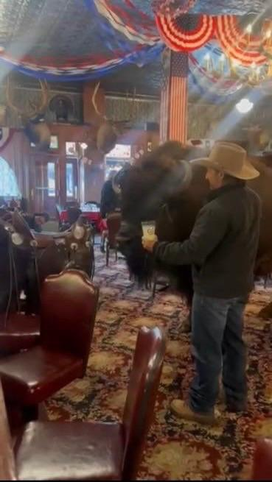



UPCOMING EVENTS

July 9 - 13: MnUSA Campout, Hill City
July 17 - 19: Iowa Campout, Cresco
July 29: Michigan Board Meeting (Zoom)
August 1 - 2: Nebraska Campout
New location: Lead, SD
August 7 - 9: Washington Summer Meeting/Campout
Pashastin/Blue Shastin RV Park
﻿

