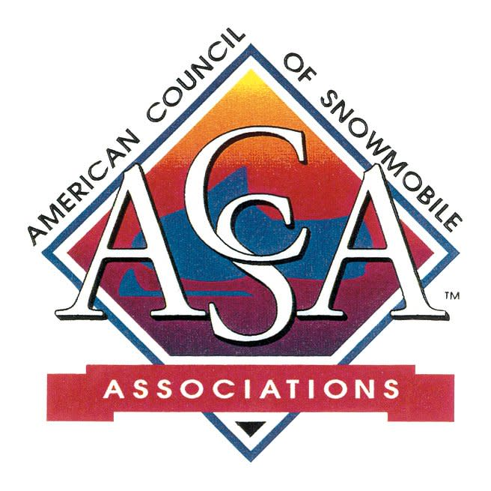

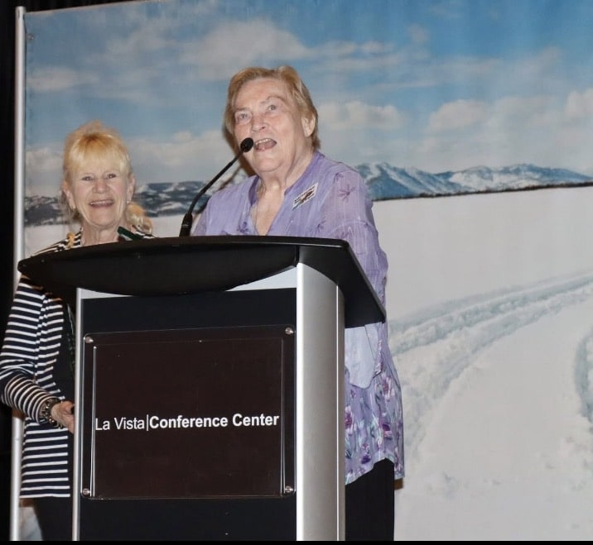

Recognizing Volunteers Never Gets Old!!
Marlys and Joann remain Volunteers Extraordinaire!!
Thanks to Marlys and Joann for their never-ending dedication and passion!

SnowBusiness Call
Polaris Grants for Trails
The monthly ACSA SnowBusiness Calls are open to snowmobilers, snowmobile clubs, state association members!
The June SnowBusiness Call will feature the Polaris Team that instrumental in the Grant Program that seeks applications 2x every year.
When: June 24th @ 8:00 pm Eastern/7:00 pm Central
Topic: Polaris Grants
Register: Click here
OR enter:
https://us06web.zoom.us/meeting/register/qhjllaanTVuUSybqesI6Mg
Understand the purpose of the program and the
Do’s and Don’ts for proposed projects!
This application process is open through August 1st.

$$$ TRAIL GRANTS $$$
The America the Beautiful Foundation has joined forces with the US Forest Service for the America 250 Trail Grant Program. The goal is at least One Project for Every Forest in the US!!
250 grants! $5,000 - $50,000!
It's open for applications NOW!

It's a short turn around!!
Initial award announcement: July 26, 2026
Completion deadline: December 31, 2027
Deferred Maintenance
Disaster/Climate Events
Less Staff - More Volunteers
Think of Trails, brushing, repairs, bridges -- the basics!
Need permitting, engineering, surveys -- here's your grant!
What are the critical barriers? List them!
List all of the benefits of the project!
Don't have Agreements with the Forest Service in place? Don't worry -- apply! Use your own application!
A new Collaborative Trail Work Agreement will be released by the Forest Service next week. We will share as soon as it is available.
This is a great opportunity! Yes - it's summer, and snowmobile clubs are not necessarily meeting. But don't let this opportunity pass you by!
Click here for the America 250 Grant Trail info.

National Recognition for RTP
The Oregon State Snowmobile Association (OSSA) has been selected as one of only ten recipients nationwide of the 2026 Tom Petri Recreational Trails Program (RTP) Annual Achievement Awards presented by the Coalition for Recreational Trails.
OSSA received the Enhancement of Federal Lands Award for our Statewide Heavy Trail Restoration Project, which improved and restored snowmobile trail infrastructure on federal lands throughout Oregon.
Projects like this demonstrate what can be accomplished when snowmobile clubs, volunteers, public land managers, contractors, and recreation partners work together toward a common goal.
Congratulations to the Oregon State Snowmobile Association! Because of the partnerships the OSSA has created, Oregon's snowmobile trails remain accessible, safe, and enjoyable for current and future generations.
The Awards Ceremony for the CRT Awards is next week in Washington, DC. It's always nice to see a snowmobile winner in the recipients!

2026 ISC Pics

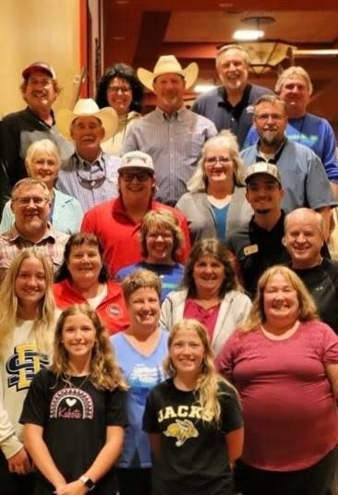

Above: South Dakota Snowmobilers
Below: Wisconsin was well represeted!

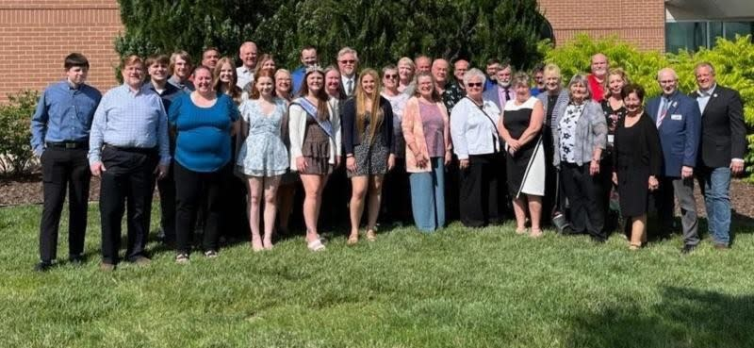

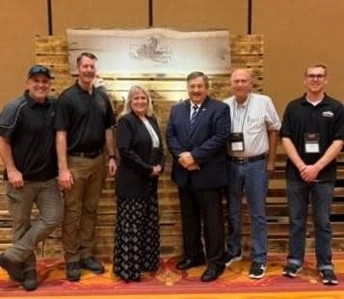

Above: Oregon leadership and partners
Below: Michigan contingent did not disappoint

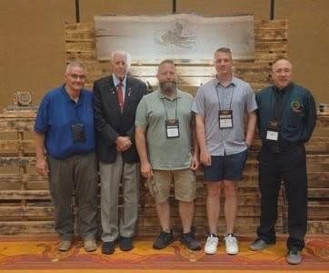

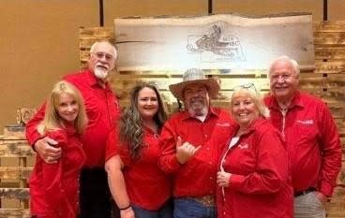

Above: Montana is always bright and smiling
Below: Illinois showed up big time

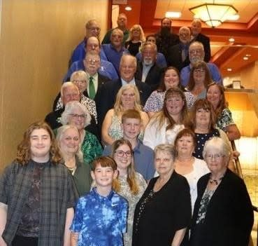

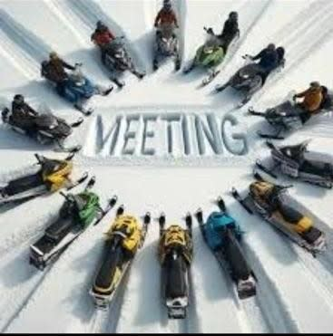

UPCOMING EVENTS
June 24: POLARIS Grant Program @ SnowBusiness
8:00 pm Eastern Zoom Call
June 27: Montana Board Meeting, Helena
July 9 - 13: MnUSA Campout, Hill City
July 22: Michigan Board Meeting (Zoom)

GET SOCIAL WITH US!
Follow us on Facebook
Click Here
P.O. Box 1670, Brighton, MI 48116
(517) 351-4362 | Email

