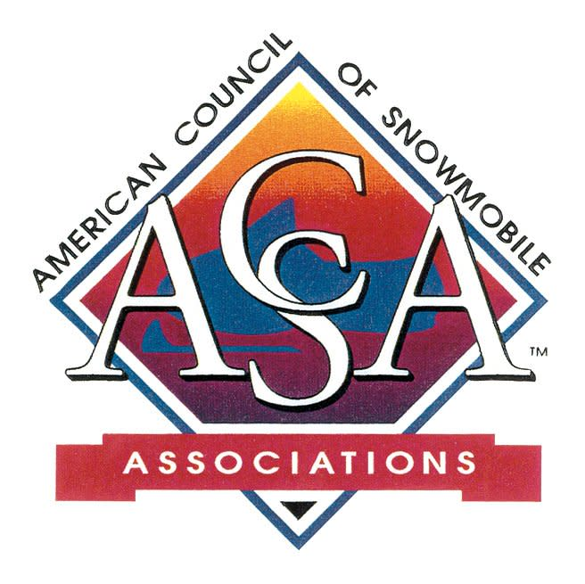

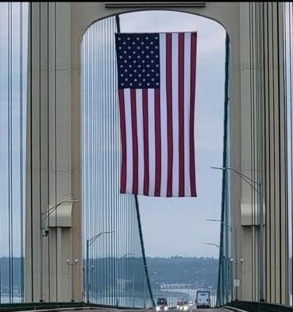

To those in uniform serving today and
to those who have served in the past,
we honor you today and every day.
ACSA wishes everyone a happy
and safe Memorial Day weekend!

SnowBusiness Call
Snow PASS Grants: Protect. Access. Sustain. Support
The monthly ACSA SnowBusiness Calls are open to snowmobilers, snowmobile clubs, state association members!
The May SnowBusiness Call will feature Ski-Doo 's PR and Media Relations Manager Steve Cowing.
When: May 27th @ 8:00 pm Eastern/7:00 pm Central
Topic: Ski-Doo Snow PASS Grants
Register: Click here
OR enter:
https://us06web.zoom.us/j/81347199657?pwd=gZ6HBvFzWsmwjGEIoa9mIGUHAUmHFB.1
Understand the purpose of the program and the
Do’s and Don’ts for proposed projects!
This application process is open through July 31st.

WE NEED YOU!!
Recreational Trails Program
There was a markup hearing this week in the Senate which included the Recreational Trails Program. This is the 1st hearing on the RTP that has been so very valuable to the snowmobile community since 1991. Unfortunately, there was no increase in the Senate language.
It appears, the RTP is not in the initial language on the House version.
RTP - and snowmobiling is very important to rural America. Take time to meet with your Senator/Congressman when they are home and holding listening sessions or meetings!
RTP is currently scheduled to expire September 30, 2026.
Contact the ACSA office if you need talking points or assistance!

BLM
Last week the Trump administration repealed the Bureau of Land Management's Conservation and Landscape Health Rule, commonly known as the Public Lands Rule.
This rule put conservation on equal footing with mining, logging, and grazing of public lands. Conservation considerations were elevated over the original mission of the BLM with the Public Lands Rule. Now it appears the BLM will focus on the historical uses, such as energy development, mining, logging, grazing and recreation.

The BLM administers approximately 244 million surface acres of public land and approximately 713 million acres of federal subsurface mineral estate in the US.

Do You Know?
Friends of Snowmobiling Political Action Committee was started several years ago. This is a program that opens doors to federal legislators and federal legislative candidates!
Want to more or want get involved? Give Dan Long a call.
ACSA has a Legal Fund, started many years ago. This is available to snowmobile clubs and associations through an application process. For additional information, contact the ACSA office or any ACSA officer.
Both of these events hold fundraisers during the International Snowmobile Congress each year.

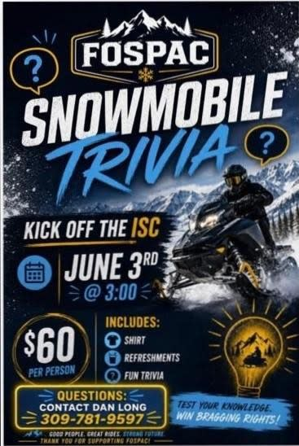

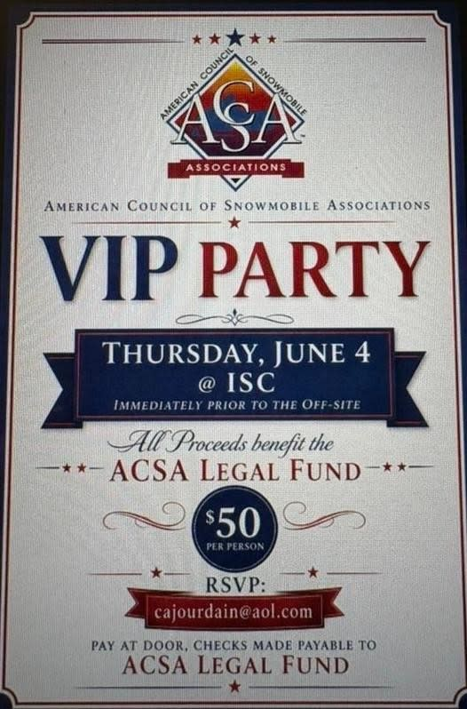

TreadLightly!
TreadLightly! (TL) has long been a provider of education for outdoor ethics. Recently BRP partnered with TL for 3 education projects for Snowmobiling, Off-Roading and PWCs.
BRP has pledged $35 for TL’s stewardship projects for each person that completes each the short - informative online courses.
This is a win-win - you get an education refresher and support TL’s trail stewardship projects!
Click here for the courses
OR enter:
https://treadlightly.org/responsibleridermasterclass/



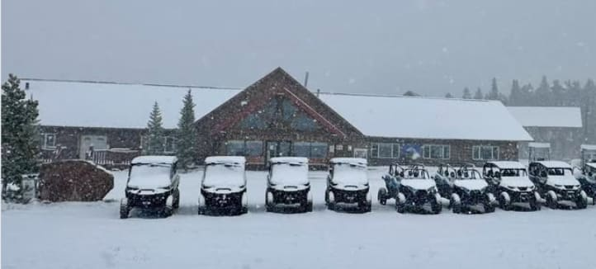

Above: A location many of us recognize -- covered with fresh snow again....May 21st....snowing in WY!
Below: Arriving at your favorite dealership now!

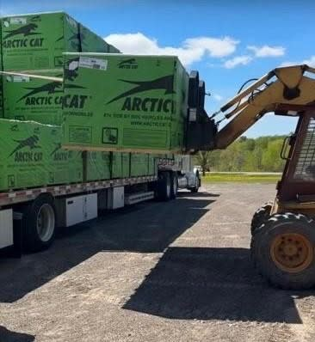

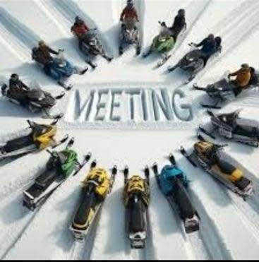

UPCOMING EVENTS
May 27: SKI-DOO PASS Grants @ ACSA SnowBusiness
8:00 pm Eastern Zoom Call
Register: https://us06web.zoom.us/j/81347199657?pwd=gZ6HBvFzWsmwjGEIoa9mIGUHAUmHFB.1
2026 ISC: June 3 - 6 Omaha, NE - click here
June 24: POLARIS Grant Program @ SnowBusiness
8:00 pm Eastern Zoom Call

GET SOCIAL WITH US!
Follow us on Facebook
Click Here
P.O. Box 1670, Brighton, MI 48116
(517) 351-4362 | Email

