==== ACSA E-News ====

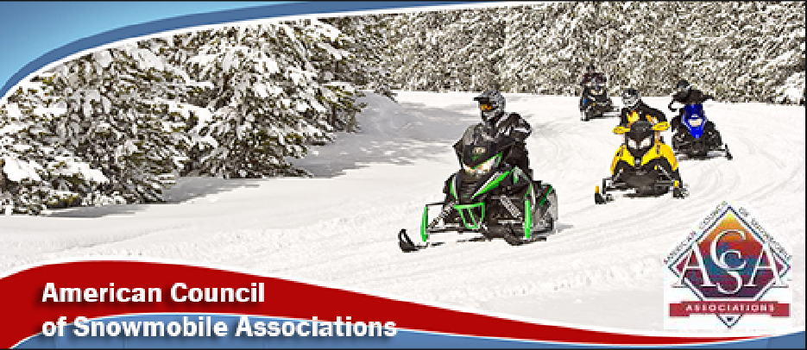

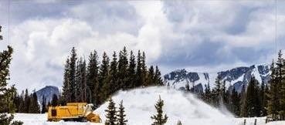

Laramie, Wyoming may not have gotten ample snow this winter - but they've been getting ample spring snow!

WE NEED YOU!!
﻿Coalition for Recreational Trails Nominations

The Coalition for Recreational Trails shared the call for nominations for their upcoming awards.
With this program expiring September 30 - we need to show the importance of these funds for our trails!
You spend RTP funds on trails, from maintenance to equipment to enhancements. SHOW OFF YOUR WORK!
Please consider submitting a nomination for a completed project which utilized RTP funds.
Click here for details and the nomination form.
﻿Deadline: May 20th!

Wyoming and Yellowstone
Wolf Numbers Decrease
A deadly outbreak of canine distemper has contributed to Wyoming’s lowest wolf population since the early 2000s. The wolf population is now at the lowest level since the reintroduction era.
Despite the disease-driven decline, most remaining wolves now have strong antibodies, and state biologists are upbeat about the species’ ability to rebound.

New Dashboard Provides Natural Resource Data
A new dashboard has been created that shares information such as how much lumber the nation produces, where invasive grasses are spreading across rangelands in a region, or how much water agricultural producers in a county use.
This tool was created by the Science for the Future and shows status, trends and futures of natural resources now and projects through 2070 using maps, graphs and other interactive elements. Created by Forest Service researchers, the dashboard uses the 2020 Resources Planning Act Assessment as its data source and distills that data into easy-to-understand information.
Click here to find the information.

SnowBusiness Call
Snow PASS Grants: Protect. Access. Sustain. Support
The monthly ACSA SnowBusiness Calls are open to snowmobilers, snowmobile clubs, state association members!
The May SnowBusiness Call will feature Ski-Doo 's PR and Media Relations Manager Steve Cowing.
When: May 27 @ 8:00 pm Eastern/7:00 pm Central
Topic: Ski-Doo Snow PASS Grants
Register: Click here
OR enter:
https://us06web.zoom.us/j/81347199657?pwd=gZ6HBvFzWsmwjGEIoa9mIGUHAUmHFB.1

Understand the purpose of the program and the
Do’s and Don’ts for proposed projects!
This application process is open through July 31st.

TreadLightly!
TreadLightly! (TL) has long been a provider of education for outdoor ethics. Recently BRP partnered with TL for 3 education projects for Snowmobiling, Off-Roading and PWCs.
BRP has pledged $35 for TL’s stewardship projects for each person that completes each the short - informative online courses.
This is a win-win - you get an education refresher and support TL’s trail stewardship projects!
Click here for the courses
OR enter:
https://treadlightly.org/responsibleridermasterclass/



Do You Know?
Friends of Snowmobiling Political Action Committee was started several years ago. This is a program that opens doors to federal legislators and federal legislative candidates!
Want to more or want get involved? Give Dan Long a call.
ACSA has a Legal Fund, started many years ago. This is available to snowmobile clubs and associations through an application process. For additional information, contact the ACSA office or any ACSA officer.
Both of these events hold fundraisers during the International Snowmobile Congress each year.







UPCOMING EVENTS
May 16: MISORVA Board Meeting - Benzie Manistee Clubhouse
2026 ISC: June 3 - 6 Omaha, NE - click here

GET SOCIAL WITH US!

Follow us on Facebook
Click Here

P.O. Box 1670, Brighton, MI 48116
(517) 351-4362 | Email



