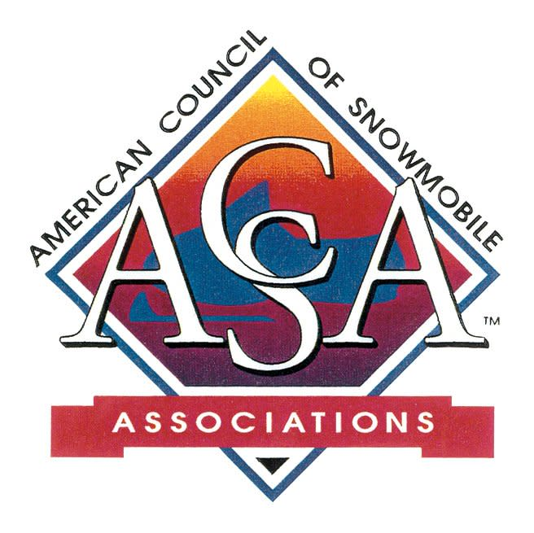

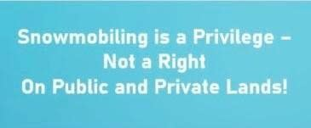

Farm Bill Goes to Senate

With a bipartisan vote of 224-200, the House of Representatives passed HR 7567, the bipartisan Farm, Food, and National Security Act of 2026, this week.
In addition to extensive updates to food and agriculture programs in a budget-neutral package, this vote marks the farthest a farm bill has made it in Congress since the most recent reauthorization was signed into law in 2018.
After a series of floor debates and last-minute amendments, the bill now moves to the Senate with some notable changes, including:
- Year-round E15 sales removed from bill to be voted on in 2 weeks
- Pesticide liability protections were stripped from the bill

Ohio farmer and National Corn Growers Association President Jed Bower said USDA programs are important to the success of corn farmers and rural communities, particularly as growers face their 4th year of net losses and struggle with high input costs.

“We look forward to working with our allies in Congress over the next two weeks to secure passage of the E15 legislation,” Bower says. “Thanks to continued efforts on this issue from our biofuel champions, Speaker Johnson promised a vote on E15, and we refuse to allow a handful of multi-million and multi-billion-dollar energy companies to derail our efforts."

Coalition for Recreational Trails

This week the Coalition for Recreational Trails shared the call for nominations for their upcoming awards.
Please consider submitting a nomination for a completed project which utilized RTP funds.
Click here for details and the nomination form.
Deadline: May 20th!

BLM Public Lands Rule
Last week the Trump administration moved a step closer to undoing a Biden-era environmental policy that elevated the standing of conservation on hundreds of millions of acres of public land.
Called the conservation and landscape health rule, the policy allowed the Bureau of Land Management to consider conservation as a use of public lands akin to other uses like oil and gas development, grazing, or recreation. The measure, which was also called the public lands rule, provided for a new type of “conservation leasing,” which would allow parcels of public land to be leased specifically to pursue landscape restoration.

Industry groups, recreation groups and others denounced the rule when it was proposed during the Biden administration. The Interior Department in September rolled out a plan to revoke it.

SnowBusiness Call

The monthly ACSA SnowBusiness Calls are open to snowmobilers, snowmobile clubs, state association members!
The May SnowBusiness Call will feature Ski-Doo 's PR and Media Relations Manager Steve Cowing.
When: May 27 @ 8:00 pm Eastern/7:00 pm Central
Topic: Ski-Doo Snow PASS Grants
Register: Click here

OR enter:
https://us06web.zoom.us/j/87574714262?pwd=fWJRwtNDccal79drxIcdceFpBoqjXV.1
Snow Pass Grants: Protect. Access. Sustain. Support
Understand the purpose of the program and the
Do’s and Don’ts for proposed projects!
This application process is open through July 31st.
Click here for the Snow PASS Grant Application

TreadLightly!

TreadLightly! (TL) has long been a provider of education for outdoor ethics. Recently BRP partnered with TL for 3 education projects for Snowmobiling, Off-Roading and PWCs.
BRP has pledged $35 for TL’s stewardship projects for each person that completes each the short - informative online courses.
This is a win-win - you get an education refresher and support TL’s trail stewardship projects!
Click here for the courses
OR enter:
https://treadlightly.org/responsibleridermasterclass/



Club Trail Volunteerism Survey
Clubs - help us get the message out!

The International Snowmobile Council (ISC) conducts their annual Club Trail Volunteerism Survey in March and April each year. There is much volunteer work that takes place to establish and maintain our snowmobile trails.
We want to gather this information so that our survey results can be made available to share with the public, Legislators, and others to learn what it takes to operate a snowmobile trail.
We need all clubs to respond to the survey Some clubs have received the survey information from the State Associations.
If you did not receive the ISC Survey or have not yet completed it, please do so. We really need your help.
If you do not have all your information gathered for this season, please use your last season information.
Here are the links to complete the survey:
Club Link: click here
The ISC greatly appreciates your time and willingness
to complete the Club Trail Volunteerism Survey!



Are You Registered
for ISC in June?

Get your room reservations!! Room book closes May 12.
Hotel Block closes 5/12 or when full.
Click here to get your registration in!
Click here for the Agenda. Great variety of Educational Breakouts in addition to meetings and social gatherings.

Michigan's UP Had Snow!
Houghton showed just over 360 inches for the winter

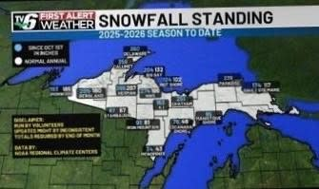

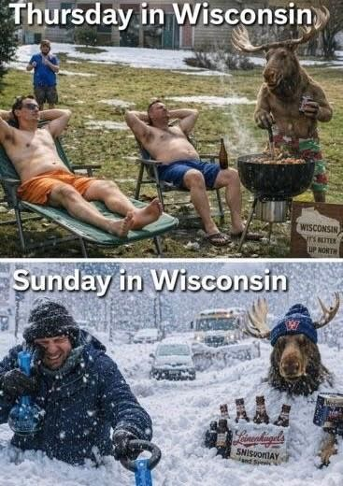

Above: Is it Spring?
Below: It is Spring in Some Areas!

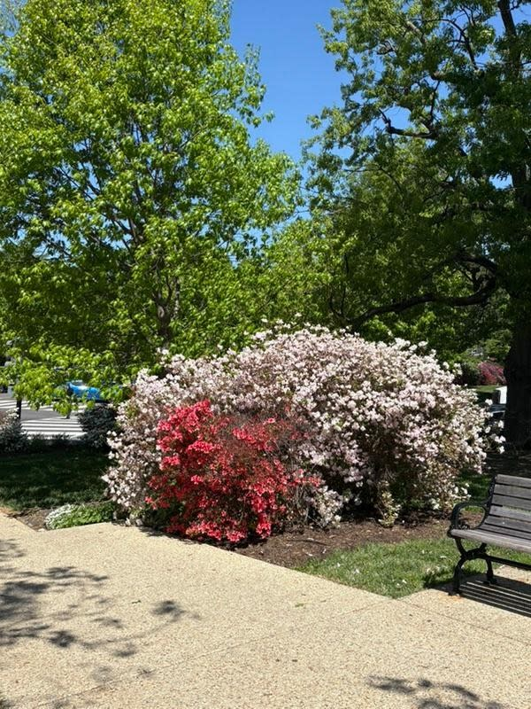

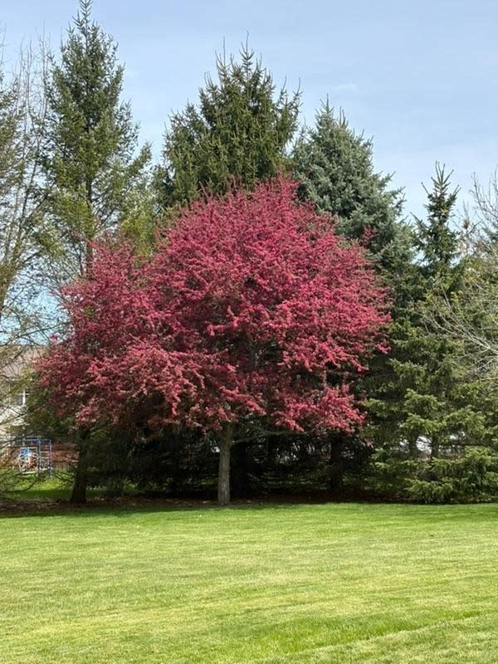



UPCOMING EVENTS
May 16: MISORVA Board Meeting - Benzie Manistee Clubhouse
2026 ISC: June 3 - 6 Omaha, NE - click here

GET SOCIAL WITH US!
Follow us on Facebook
Click Here
P.O. Box 1670, Brighton, MI 48116
(517) 351-4362 | Email

