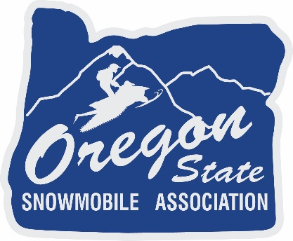

**KEN HAEVERNICK OREGON STATE SNOWMOBILE ASSOCIATION  
 2025 SCHOLARSHIP APPLICATION**

OSSA scholarship is available to either graduating high school seniors or a person currently enrolled in a college or trade school full time (12 semester credits), either physically or online. Scholarships will be given to the winners regardless of other grants or scholarships that the students may receive.

**Requirements are as follows:**

1. The applicant or immediate family must be a paid member of Oregon State Snowmobile Association.
2. The applicant must submit the completed application form.
3. The applicant must submit a cover letter. This letter must include the student ID number and college/trade school name and the address to which a scholarship check would be sent.
4. The applicant must submit a resume detailing his/her involvement in snowmobiling as well as extra-curricular/volunteer activities.
5. The applicant must include an essay (essay subject on the application form). The essay MUST follow the format below to be accepted and should be sent in Word or Google Docs:
   1. Minimum of 2 pages – typed.
   2. Double-spaced.
   3. Font – Times New Roman.
   4. Font size – 12 point.
   5. Margins – set to 1 inch for all margins (top, bottom, left side, right side).
   6. Page numbers (if included) should be .5 inch from the top of the page (not within the 1” margin).
   7. A header (for example, the essay question) can be added 1 inch from the top of the first page, and then enter a double space to begin your essay.
   8. Do NOT use bold-faced type or other special settings.
   9. If work is cited, add an additional “work-cited” page at the end of the essay. This information will NOT be counted as part of the 2-page minimum.

The applicable documents must be received via email at the OSSA Office by April 1, 2025. Please email to [Lmahoney@oregonsnow.org](mailto:Lmahoney@oregonsnow.org) using a subject line of OSSA Scholarship Application. All applicants will be notified of the final scholarship selection by April 15, 2025. The scholarship winner will be announced at the OSSA Board Meeting in May 2025.

1. **Any entry that does not meet ALL of these requirements will be disqualified. NO EXCEPTIONS.**

**Additional rules:**

1. Students must use the scholarship within one year of receiving it.
2. All scholarship checks will be written directly to the college and not to the student. NO EXCEPTIONS.

OREGON STATE SNOWMOBILE SCHOLARSHIP  
 2025 APPLICATION FORM

Applicant Name: _______________________________________________________________

Email: ___________________________________________ Phone: ­­­­­­­­­­­ (___) _________________

Mailing Address: ­­­­­­­­­­_______________________________________________________________

City: _________________________________________ State: ___________________________

Postal Code: _____________________

State Association: ______________________________________________________________

Member of which local Club(s)? ___________________________________________________

_____________________________________________________________________________

Graduated from what high school or GED equivalent? __________________________________

Attending which college, technical or vocational institute? _______________________________

______________________________________________________________________________

If already enrolled in a program, what year are you in? _________________________________

High School or Equivalent GPA: ___________________________________________________

If applicable, college, technical or vocational GPA: ____________________________________

Have you attached a cover letter introducing yourself and provided your student ID number and your college/trade school name and address to which a scholarship check would be sent?

Have you attached a resume detailing your involvement in snowmobiling  
 as well as extra-curricular school activities?

Have you attached an essay on the following subject (must be at least 2  
pages, double-spaced and typed)?

OREGON STATE SNOWMOBILE SCHOLARSHIP  
 2025 APPLICATION FORM

**Essay Topic:**

A week after President Biden took office, he signed an executive order that announced his commitment to protecting 30% of U.S. land and water by 2030.

**Essay Challenge:**

* How does this executive order impact snowmobiling?
* What action should snowmobilers take on the order?

Note:

Essays will be judged on depth of content, clarity, organization, and persuasiveness.