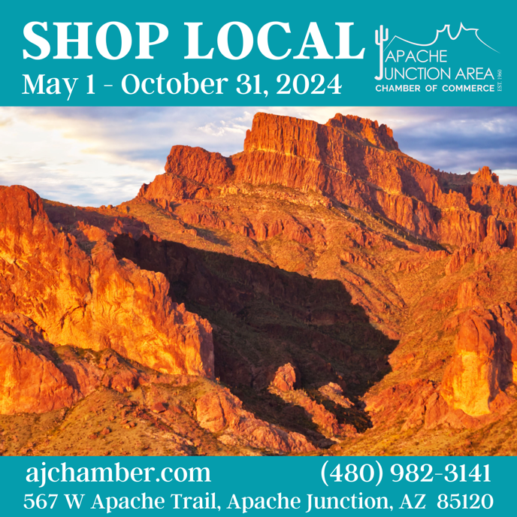

**10% Discount**

**A&A Cooling and Heating**

Off service or maintenance

386 S Ironwood Dr, AJ

480-757-1440

**Apache Junction – Gold Canyon Independent** **News**

10% off an advertisement in the newspaper. Good for all ad sizes, print and YourValley.net only. Contract optional.

623-972-6101 or azads@iniusa.org

**Brown Bear BBQ Food Truck**

Food truck menu items only

480-298-0301 – Phil

**Café Mix 2 Restaurant** *(closed Sun)*

1408 W Apache Trail, AJ

480-982-9486

**ComeForCare Home Care**

10% off first month of home care

602-438-1300

**Divine Signs and Awards**

1020 N Meridian Dr, AJ

480-986-9933

**Gold Stallion Restaurant**

(does not include alcohol)

6030 S Kings Ranch Rd, Gold Canyon

480-935-1998

**Fatman’s Pizza** *(closed Mon)*

2430 W Apache Trail, AJ

480-671-9897

**Hair Brilliance**

10% off hair products. Veteran’s discounts year-round.

2125 W Apache Trail, Ste 103, AJ

480-904-39924

**Harris Tax Accounting Services**

10% off tax services or accounting setup for

*NEW customers only*

1000 W Apache Trail, Ste 100, AJ

480-605-3710

**Kabat’s Frontier Ace Hardware**

(does not apply to sale items; other exclusions may apply)

725 W Apache Trail, AJ

480-983-9223

**Mickey D’s Café** *(closes 1pm daily)*

1408 W Apache Trail, AJ

480-671-5755

**Mother Lode Mercantile**

4650 N Mammoth Mine Rd, AJ

480-983-4500

**No Reason Why Flowers**

10% off purchase of $30 or more

185 N Apache Trail, AJ

480-297-8920

**Scott’s Automotive of Apache Junction**

10% off a service up to $150. Cannot Combine with other offers or coupons. Excludes oil changes, tires and brakes.

2085 W Apache Trail, AJ

480-690-3555

**15% Discount**

**Big O Tires**

15% off any repair service. Not applied to tires or shop supplies. Cannot combine with other offers or coupons.

35 S Idaho Rd, AJ

480-428-3199

**Cat Wagon Tap & Bottle**

2430 W Apache Trail, Ste 4, AJ

480-982-7100

**CStone Show Productions**

Peddler’s Mall, Booth 129

185 W Apache Trail, AJ

480-474-2054

**Hair Brilliance**

15% off haircuts with other service (color/highlights). Veteran’s discounts year-round.

2125 W Apache Trail, Ste 103, AJ

480-904-39924

**Hope’s Boarding Camp & Doggie Day Care**

460 S Colt Rd, AJ

480-288-2959

**Los Gringos Locos Grill & Cantina**

Cannot combine with other offers or coupons.

(does not include alcohol)

280 S Phelps Dr, AJ

480-288-5626

**Paladino’s Italian Eatery** *(closed Sun & Mon)*

(does not include alcohol)

300 W Apache Trail, AJ

480-983-0976

**PassTime Fun Paper**

15% off advertising rates in the paper

951 W Apache Trail, AJ

480-983-9143 – call for details

**Pickle Barrel Trading Post** *(closed Mon & Tues)*

15% off 1 full-priced item of your choice (excludes Pendleton and Consignment)

404 S Broad St, Globe

928-425-9282

**Superstition Harley-Davidson**

15% off any regular priced item in parts and accessories or MotorClothes™. Not valid on sale items.

2910 W Apache Trail, AJ

480-346-0600

**Superstition Mountain Museum**

15% off in Gift Shop; $5 Museum Admission

4087 N Apache Trail, AJ

480-983-4888

**Taco Giro Mexican Grill**

Dine-in only at Apache Junction location

(does not include alcohol)

1520 W Apache Trail, AJ

480-982-6480

**Toast Gio’s Breakfast & Lunch**

*(closes 2 pm daily, closed Tues)*

(does not include alcohol)

1422 E Broadway Ave, AJ

480-671-3955

**Tortilla Flat**

15% off mercantile purchase AND $1.50 scoop of ice cream in country store. Both discounts available with meal purchase in restaurant. Excludes local vendors.

1 Main St, Tortilla Flat, AZ

480-984-1776

**20% Discount**

**Any Hour Cleaning & Organizing**

20% off deep clean OR regular clean for new customers, plus choice of a Norwex cloth (EnviroCloth or window cloth).

Apache Junction location only

480-579-1800

**HG Coffee** *(closes 2 pm daily, closed Sun & Mon)*

20% off entire order OR buy a pound of roasted coffee and, receive a *FREE* plain 16-oz drink (hot or iced coffee, cold brew, unflavored latte, tea of chai). Limit 1 per customer; offers cannot be combined.

(inside Superstition Ranch Market)

7 N 114th Street, AJ

480-984-3568 – call for details

**Mammoth Steakhouse & Saloon**

(does not include alcohol)

4650 N Mammoth Mine Rd, AJ

480-983-6402

**The Wild Facebox**

20% off 1st service (facial or dermaplane) & product. Cannot combine with other offers or coupons. AJ location only.

2270 S Acacia Rd, AJ

602-828-9323

**ZAO Theatre**

20% off *ONLINE* ticket purchases for “Godspell: 2012 Revised Version,” playing June 14-29, 2024. Use coupon code “SUMMER” to receive discount.

6338 S Kings Ranch Rd, Gold Canyon

480-924-5122

**30% Discount**

**Budget Blinds of East Mesa**

30% off recommended retail

480-372-3649

**CLICK QR CODE TO DOWNLOAD LIST**



**Special Discounts**

**AJ First Assembly of God Church**

*FREE* book offer – “God’s “Promises for Your Every Need.” Available at church office.

651 N Ocotillo Dr, AJ

480-983-1200

**AJ Tires & Service**

$10 off a $25 or more purchase.

740 W Apache Trail, AJ

480-982-8489

**Aunt Barb’s Home Placement Services**

$25 gift card with a closed referral that results in a client placement.

550 W Baseline Rd, Ste 102-207, Mesa

602-432-1893

**Brookdale Senior Living, Apache Junction**

*FREE* signature desert and demi bottle of wine with a scheduled tour of AJ facility

2080 S Ironwood Dr, AJ

480-983-5047

**Canyon Creek Candle Company**

Save $10 on $60 online order – use “SHOPLOCAL” discount code. Free local delivery. canyoncreekcandleco.com

320-455-7345

**Elaine Berry – Team Beery at EXP Realty**

1 year Home Warranty, valued up to $500. Must be under contract by Oct 2024.

480-570-1912 – Elaine

**Farm Bureau Financial Services – Leigh Schmidbauer**

*FREE* color changing cup for anyone who stops by. *FREE* $5 gift card for anyone who gets a quote*.*

155 N Meridian Rd, Ste 102, AJ

480-626-8045 – Leigh Schmidbauer

**Jarman Insurance**

*FREE* customer appreciation gift with consultation; services Always 100% free of charge

5264 N Idaho Rd, AJ

480-255-1076

**Jenesis Southwest Interior Design**

*FREE* gift card (value depending on level of design services purchased) to local business of your choice with first purchase of design services

3400 S Ironwood Dr, Lot 1032, AJ

480-319-0229

**LegalShield & IDShield**

*FREE* $40-$170 gift card (value depending on monthly plan purchased) to local business of your choice, with new membership.

901-210-3194

**Let Your Soul Breathe – Stress Management & Holistic Healing**

$25 off first 90-minute stress management session; pay $125 vs $150.

6641 S Kings Ranch Rd, Ste 4, Gold Canyon

480-252-0842 (Bonnie)

**Phoenix Metro Towing**

$40 off any Light Duty Tow Service to any Apache Junction based dealership, repair shop, or tire shop.

2244 W Apache Trail, AJ

Dispatch: 480-423-4700

**Popeye’s Louisiana Kitchen**

*FREE* small drink with purchase of 2-piece chicken dinner. Limit 1 per visit.

75 W Apache Trail, AJ

480-591-0378

**Queen Creek Olive Mill**

Get 1 BOGO Tour/Education Class Card from the AJ Chamber; $8 value

25062 S Meridian Rd, Queen Creek

480-888-9290

**Quick Quack Car Wash**

$5 off First Month Any Membership

$5 off the “Lucky Duck” Single Wash

1310 S Signal Butte Rd, Mesa

888-772-2792

**Range Printing**

$25 off your 1st order of $200 or more of promotional or clothing items. Must call Lynn, the “girl with all the gadgets.”

701-730-4570 or [lhanson@printrp.com](mailto:lhanson@printrp.com)

**Trucks Only**

$500 off lowest advertised price. $100 off in our service dept when spending $500 or more.

837 W Apache Trail, AJ

480-671-5600

**YAK N SUP at Canyon Lake**

*FREE* dry bag rental with kayak or paddleboard rental. $10 value.

16802 AZ-88, AJ

480-420-8144