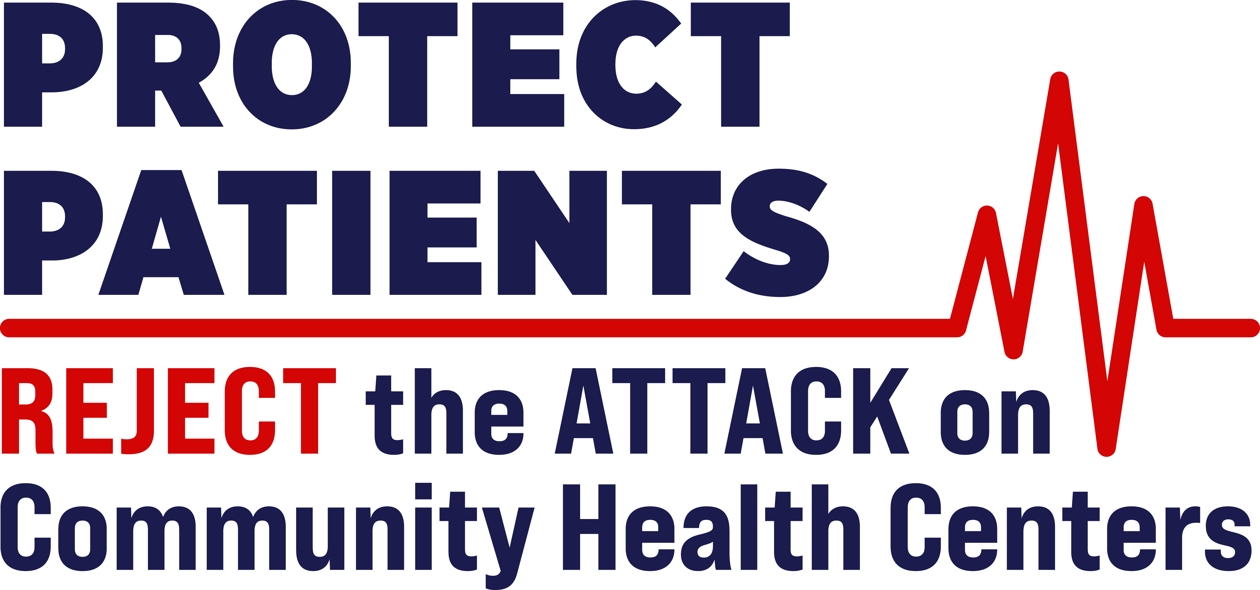

Date: 08/13/2026

To: Francisco Silva, Esq., Committee to Protect Patients: Stop the Attack on Community Health Centers and Clinics

From: Rick Wilson, President, San Diego East County Chamber of Commerce

Subject: Opposition to Proposed Ballot Measure Affecting Community Health Centers and Vulnerable Patients

Dear Francisco Silva,

On behalf of the San Diego East County Regional Chamber of Commerce, I am writing to express my formal opposition to the dangerous ballot measure targeting community health centers and clinics, which is likely headed to the ballot in California on Election Day in November of 2026. I share your deep concern about the profound and far-reaching threat this ballot measure poses to community health centers, the patients they serve, and the broader healthcare safety net across the state.

I am particularly troubled that this measure would divert billions of dollars away from patient care into new layers of bureaucracy, impose arbitrary exclusions that could defund essential services, and restrict health centers from expanding into communities where access to care is most urgently needed.

For these reasons, I am strongly urging stakeholders, community leaders, and policymakers to join us in opposition to this harmful proposal. The patients and families who rely on these services cannot afford the consequences of this measure.

I appreciate your leadership and partnership in safeguarding access to care and preserving the integrity of our community health system. I look forward to working together to ensure this measure is defeated and that our healthcare infrastructure remains strong, responsive, and centered on the needs of the communities it serves.

Sincerely,

Rick Wilson, President, San Diego East County Chamber of Commerce

Ad paid for by Protect Patients: Stop the Attack on Community Health Centers and Clinics,
​sponsored by California Primary Care Association Advocates
​Ad Committee’s Top Funders
​ AltaMed Health Services
North East Medical Services
Family Health Centers of San Diego
​Funding details at www.fppc.ca.gov

