To learn more about using this tool refer to the Section 3 in the Safe Patient Handling and Mobility: A Toolkit for Program Development 2025 at: https://www.nvha.net/safe-patient-handling-and-mobility-toolkit/
Safe Patient Handling and Mobility (SPHM) Program
Site Visit Assessment Checklist
Refer to Section 3 for information on preparing and conducting a Site Visit of Priority Units/Departments.

Safe Patient Handling and Mobility Program  - Site-Visit Assessment |  |  | ABC Hospital
Unit/Department: |  | Date of Visit:
Manager: |  | Contact #:
Person(s) Conducting Visit: Name: |  | Title:
Name: |  | Title:
Name: |  | Title:
Name: |  | Title:

Attach information gathered from the Manager Survey of Unit/Department Characteristics (Tool 3d) below. Complete missing information during the visit for the items below as needed:
Unit/Department Characteristics & Manager Information
Patient Population
Notes

Staffing
Notes

Bed & Room Configuration/Space/Maintenance/Storage/Future changes
Notes

SPHM Equipment/Maintenance
Notes

Training
Notes

Facilities Design Checklist
Indicate factors that may hinder use of SPHM technology and note potential solutions (if any).
Sketch room/area layout including measurements such as clearances relevant to SPHM equipment use.

Factor | Location | Notes
Storage Areas
Inadequate storage space
Lack of electrical charging outlets in equipment storage areas
Storage areas inconvenient to access/too far from unit/department
Storage space cluttered / unorganized
Storage shelves – too high/low/awkward to reach heavier items/placed on top and bottom shelves
Patient Rooms/Treatment Areas
Overall - small and/or cluttered rooms, bathrooms, treatment workspaces
Minimal storage in a patient room
Entrance to patient rooms is not wide enough to allow wide or expanded beds to pass through and/or easily move a stretcher in and out of a patient room/align the stretcher with the bed etc.
Insufficient space to perform tasks and maneuver equipment around beds/exam tables
Insufficient clearance for floor-based lift equipment e.g. under bed clearance
Narrow entrance into bathroom
No grab rails by toilets, in bathtubs or showers
Toilet seats too low; wall-mounted
Furniture is non-adjustable e.g. fixed height chairs/ non removable chair arms,
Adjustable features on beds/chairs etc., are require physical effort (forceful exertion) to use
Furniture is in disrepair old, worn, missing parts, etc.
Use of full bed traction, beds with fall protection canopies etc that can impede use of overhead/floor-based lifts
Protruding objects / sharp edges for patient / staff contact with movement.
Potential ceiling barriers for overhead lift installation.
Beds do not lower to accommodate egress for shorter patient. Note lowest bed height.
Poor lighting
Hallways
Steep ramps or inclines (greater than 10 degrees)
Are walkways clear and free of clutter?
General
Thresholds or obstructions in entry ways of bathrooms, showers, hallways that prevent access for assistive equipment
Door handles catch on beds, gurneys, wheelchairs or other assistive equipment
Poor floor conditions: slippery, uneven, poor repair, raised thresholds etc.
Communication Tools
Patient room information at primary nurses/staff workstation - rooms with overhead lifts could be added
A patient’s SPHM needs could be noted on existing communication tools in patient rooms e.g., white boards or there is a location for posting SPHM info. Safety alerts used e.g. fall risk; risk of violence labels on doors – feasibility to add SPHM mobility related signage
Signs with safety and procedural related SPHM information can be posted in staff work areas, storage areas etc.
Other

SPHM Technology Inventory
Use the SPHM Technology Inventory Survey (Tool 3e) to complete assessment of existing SPHM equipment, slings and other mobility assistive devices.

SPHM Procedures
Talk to caregivers and support services staff including charges nurses, specialty/clinical practice leaders and clinical educators, rehabilitation therapists, diagnostic imaging technologists, respiratory therapists, transporters etc., to gain their perspectives on patient handling needs, processes, unit culture, education, and training processes etc.
Confirm/clarify information from previous hazard assessment activities such as gap analysis, employee surveys and interviews etc., related to processes that will impact use of SPHM technology such as mobility assessment protocols, environmental service cleaning protocols, linen handling etc., and patient handling tasks you are not able to observe during the site visit such as fall recovery.
Notes

Patient Handling Task Observation
Complete the following for each patient handling task observed. Refer to Section 3 for more information.
Use the data collected through staff surveys to determine unit/dept. specific tasks that should be observed.
- Determine the root cause of physical risk factors and poor work practices observed.
- Determine if caregivers follow any existing SPHM equipment instructions/protocols. If protocols are not followed find out and record, why.
- Note if further formal ergonomics evaluation is needed.
- Discuss potential solutions and barriers to solutions with caregivers.
Room #/Location:  Patient Handling Task Observed: | Relevant patient demographics (non-identifiable/HIPPA compliant) such as weight; clinical conditions etc: | # Caregivers observed and job title (CNA, RN, PT/OT etc.):

Factor | Observations/Root Cause | Potential Solutions
Physical Risk Factors
Forceful exertion associated with lifting, pushing & pulling, carrying, and gripping
Awkward postures -e.g., reaching, bending, twisting, kneeling, squatting etc.* Note part of body affected
Sustained or static postures
Unstable or unbalanced postures
Repetitive movement
Exposure to environmental factors such as vibration, extreme heat or cold
Other
Work Practices
Use of pre-task mobility assessment or check, or information about the patient’s mobility status to determine how the task is to be performed.
Enough staff to perform the task & other caregivers available if needed
Preparation of workspace to reduce hazards; gathers supplies needed
Communication between the patient and caregiver(s)
Communication between caregivers and how well the task was coordinated
Encouraged patient to assist as much as possible
Use of SPHM technology (if available); if appropriate for task and used correctly
Caregiver clothing appropriate to allow ease of motion; footwear with poor traction
Caregiver (s) lacks knowledge or training
The Patient
Ability to assist during task & reasons for any limitations e.g., Clinical condition/diagnosis and physical limitations
- Cognitive issues such as confusion and dementia
- Language and cultural differences
- Client anxiety and fear of moving
- Pain
- Medical attachments to client
The patient’s experience during the task. If feasible, ask the patient if they felt safe and comfortable during the task
Other

The Physical Environment – Also refer to Facilities Design Checklist
Physical layout of the room or work area e.g.,
- Access to three sides of a patient’s bed, and/or chair and toilet; other space limitations e.g., equipment, clutter, etc.
- Access and clearance to patient surfaces if lift equipment is being used
- Slip, trip, and fall hazards such as wires and wet floors
- Poor lighting
Other

*Refer to Appendix A, Section 1 and Tool 1a for information about awkward postures and other risk factors associated with manual patient handling tasks and Section 10 for information about ergonomics and risk factors for musculoskeletal disorders.
Additional Observations/Notes

Closing Conference Notes
Document and discuss any safety related hazards or issues that need to be addressed immediately with the unit/department manager (and/or shift charge nurse or supervisor as needed). Follow your facility protocol for reporting and addressing urgent safety hazards.
Note if a follow-up visit to the unit/dept. is needed to gain more information etc.
Notes

APPENDIX A
Examples of Neutral and Awkward Postures
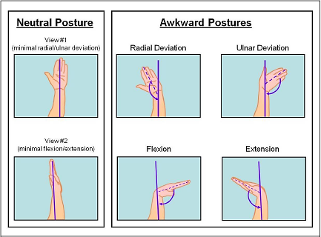

Neutral and awkward wrist postures.

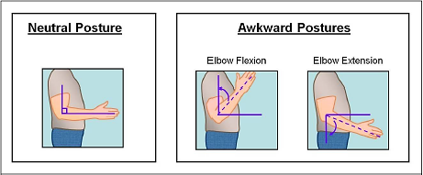

Neutral and awkward elbow postures.

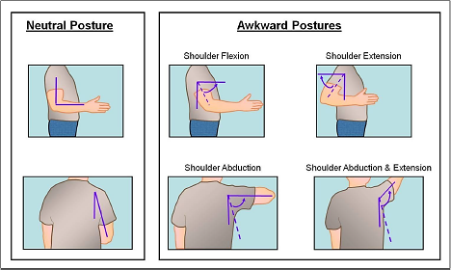

Neutral and awkward shoulder postures

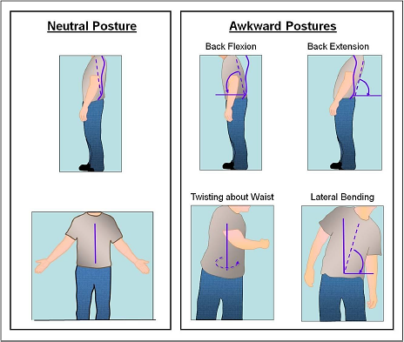

Neutral and awkward back postures.

Not shown – squatting, kneeling, abduction & adduction of legs, and flexion, extension and deviation of ankles/feet.

Source: Moore S., Torma-Krajewski, J., & Steiner, L.(July 2011) Practical Demonstrations of Ergonomic Principles. Report of Investigations 9684. Centers for Disease Control and Prevention. National Institute for Occupational Safety and Health. https://www.cdc.gov/niosh/media/pdfs/2011-191_demonsttaion-of-ergonomic-principles.pdf

