Recruiting, Retaining, and Leading Volunteers


www.HardySmith.com

Developing Your Volunteer Program

- What is purpose of your volunteer program? Include specific goals.

- What is need for volunteers? (single event or ongoing?)

- What are anticipated (measurable) results?

- What are specific tasks for volunteers?

- How many volunteers are needed?

- What is staff role?

- How will you achieve staff support?

- What resources are needed?

- What is budget for this program?

- What are key dates for program implementation?

- How will volunteers be supervised?

- How will volunteers be recruited?

- What skills and experience are needed?

- How will volunteer prospects be evaluated?

- What training will be required? (For both staff and volunteers)

- How can current volunteer experience be improved?

- What is communication plan?

- What is current volunteer retention rate?

- How can retention rate be improved?

- How will volunteers be recognized?

- How will program evaluation be done?

- What are mistakes to avoid?

- What other planning steps should be considered?

- How can planning process be used to build engagement of program stakeholders?

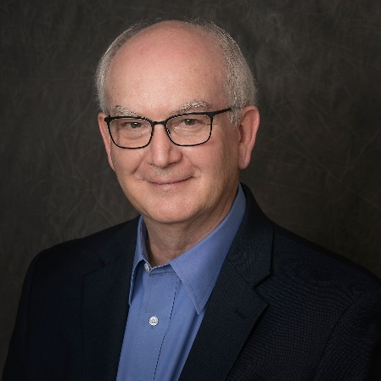
Hardy Smith, IOM

Hardy Smith is author of Stop The Nonprofit Board Blame Game. He works with associations, chambers of commerce, and nonprofits who want to benefit from a fully engaged board.
As a consultant, executive coach, and speaker, his results-oriented approach is based on a career of more than 30 years in the high performance world of NASCAR racing.
His extensive nationwide professional and personal involvement with associations, chambers of commerce, and nonprofits includes numerous local, state, and national volunteer leadership positions.
He has certifications in nonprofit management, volunteer administration, and personality assessment.
Hardy’s original research to answer the compelling question, Why Don’t Board Members Do What They’re Supposed To Do? provides a unique perspective for speaking and board development sessions.
He has a large social media following and publishes a widely read newsletter for association, chamber, and nonprofit leaders.
Hardy is a U.S. Chamber of Commerce Foundation’s Institute for Organization Management faculty member and has earned the Institute’s IOM designation.
He is a member of the National Speakers Association, Association of Fundraising Professionals, BoardSource, Florida Society of Association Professionals, ASAE, and Association of Chamber of Commerce Executives.
Learn more about Hardy and see testimonials by visiting his website: www.hardysmith.com

Contact Information: 386-451-0652 / Hardy@hardysmith.com

